**Practical 7**

**AIM :** Implement a Wireless Network Sensor Simulation

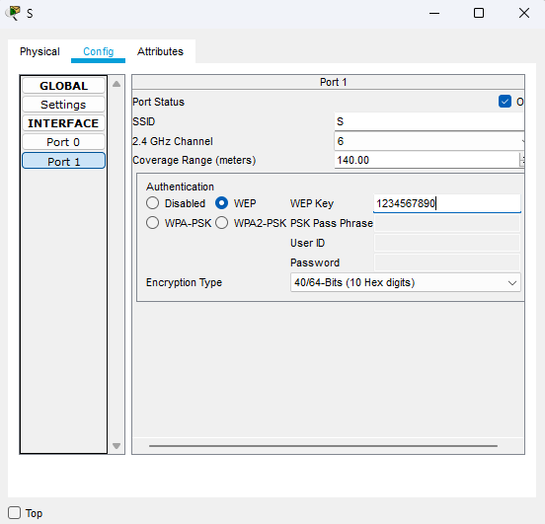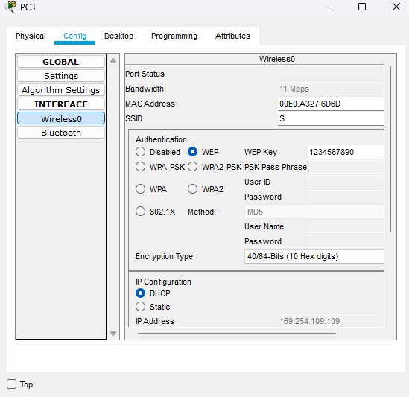

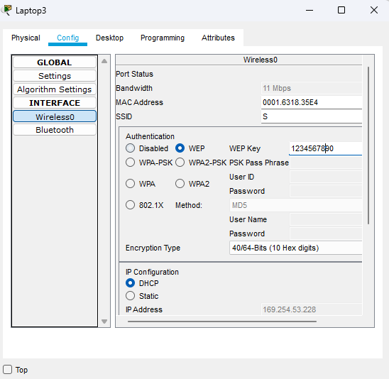

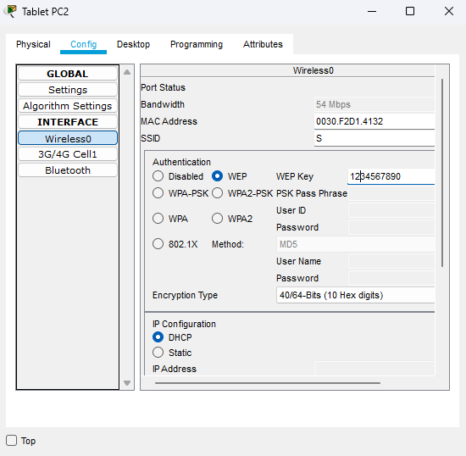

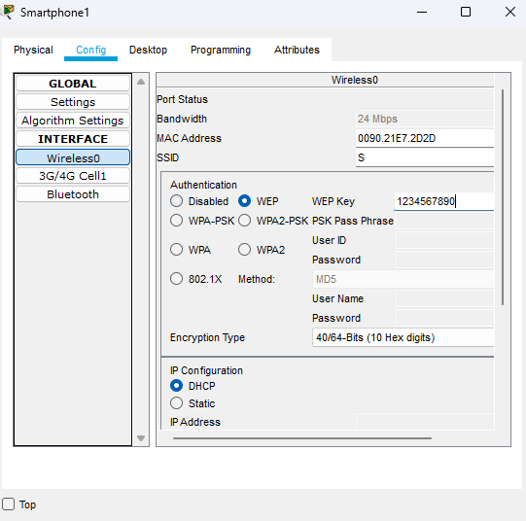

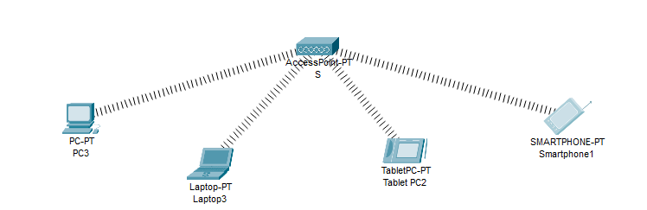

**Practical 7B**

**7 Aim: Implement a wireless sensor network simulation.**

1)Concider following topolody.

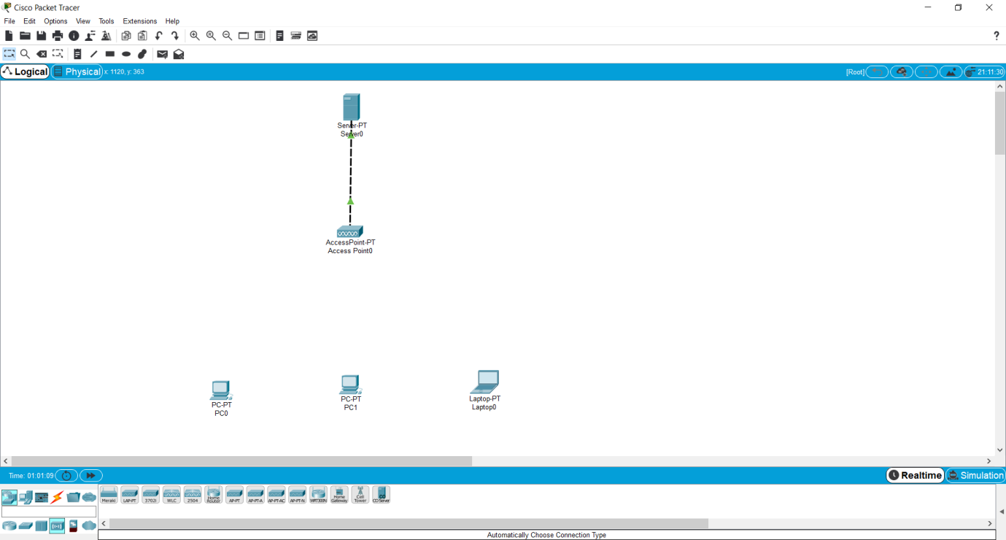

Double click on pc and tuen off power choose suitable connection for wireless network then tuen on

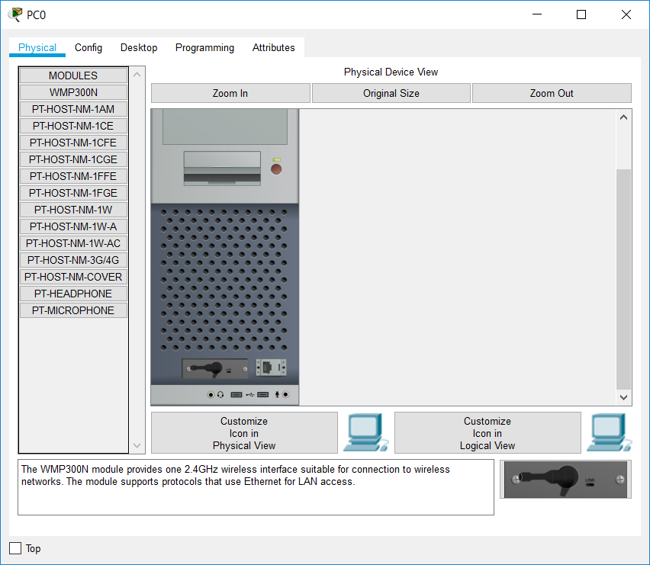

Automatic connection created.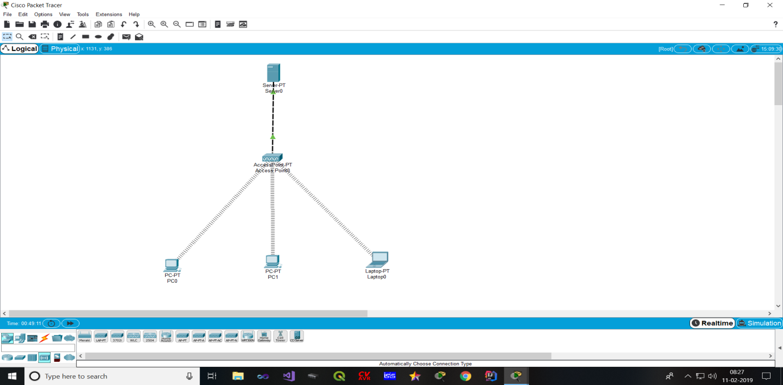

Double click on server and set the ip address

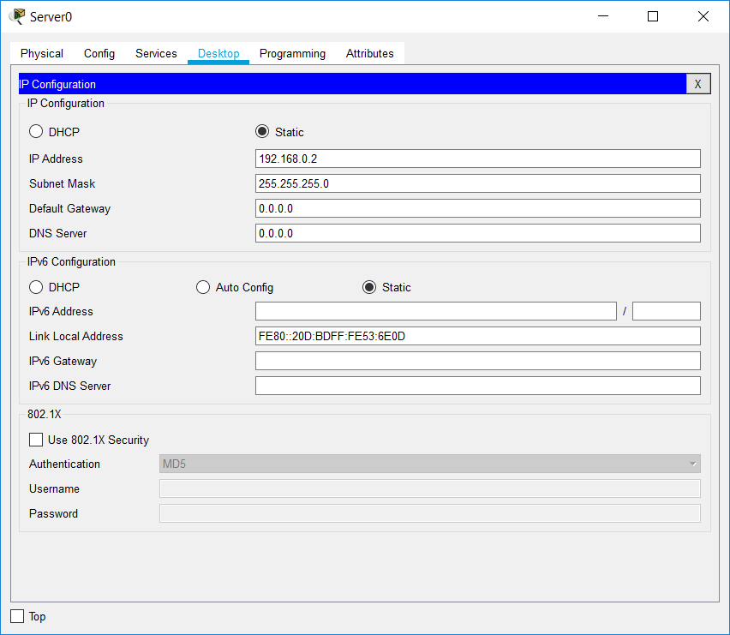

Then open service turn on DHCP setting

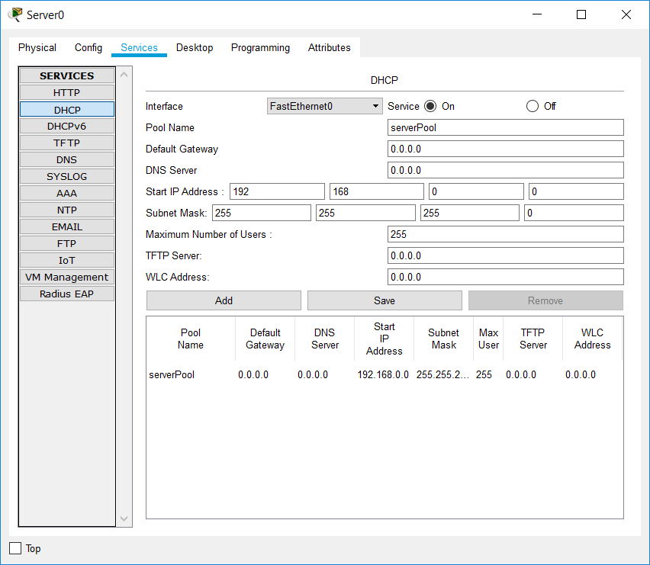

Then turn on pc’s DHCP setting.

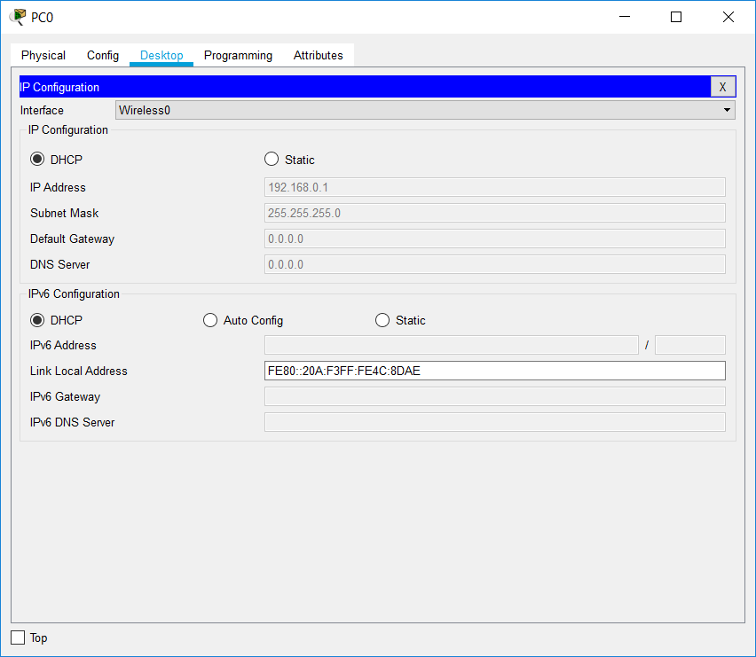

Check the ping command.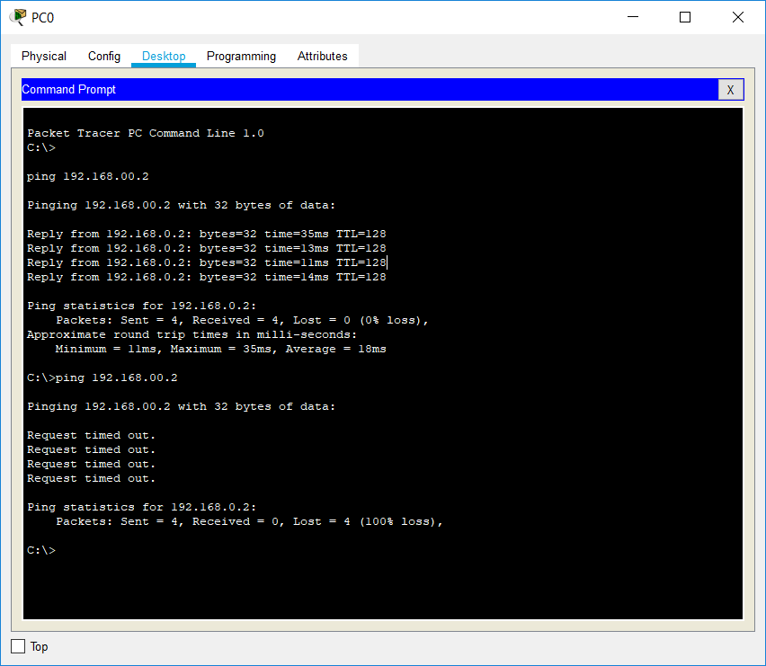

For SSID

SSID is service set identifier it is use as a mail to identify a wireless router to connect to.

Wireless router have default SSID is when first set up and can be rename to more descriptive name

For eg ”college _wifi” to set this open the access point

Open accesspoint setting set the SSID as college_wifi.After that connection is loss. 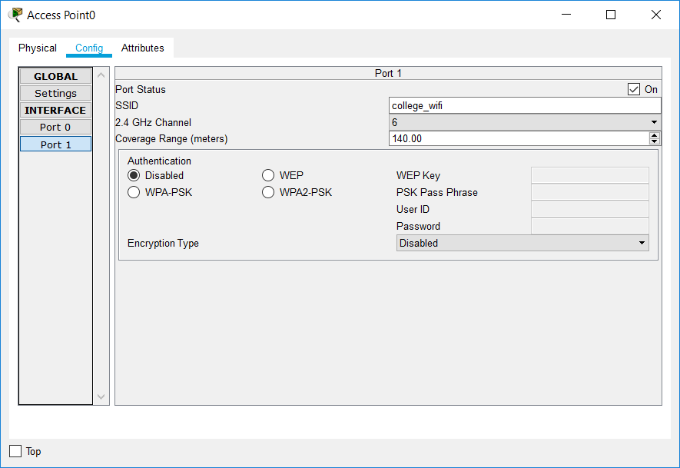

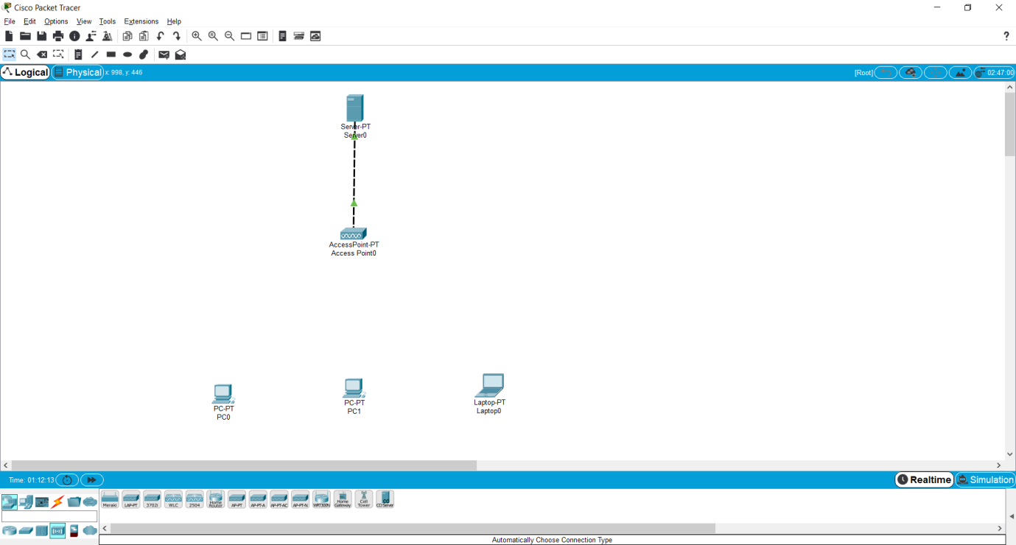

Set the SSID to pc0 and laptop

Open pc0 setting and set the SSID as college_wifi.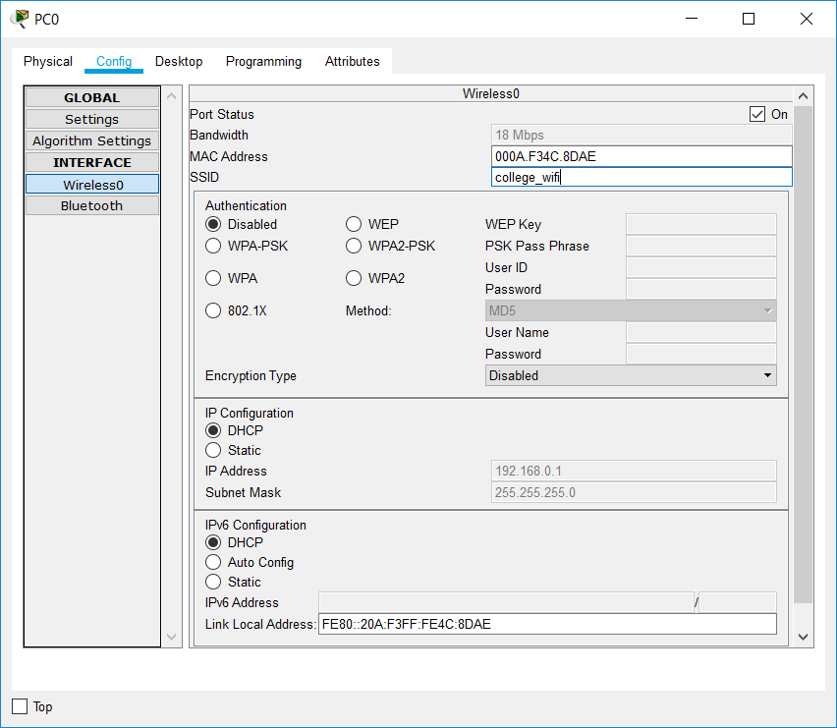

After that pc0 network automatic connected.

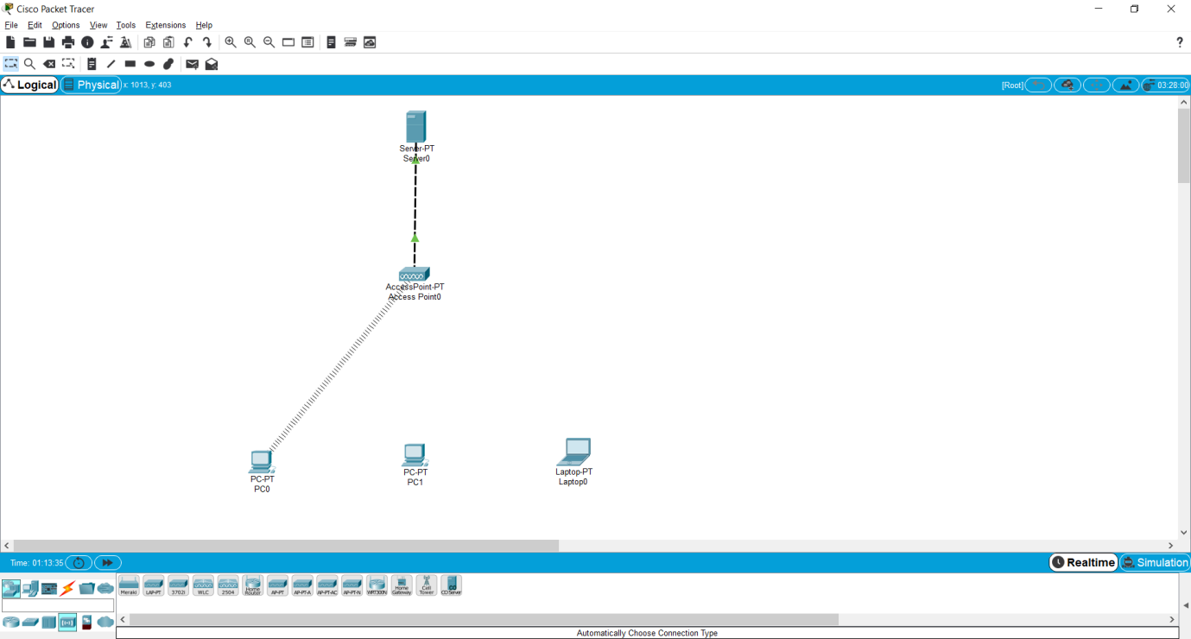

Check the ping command.